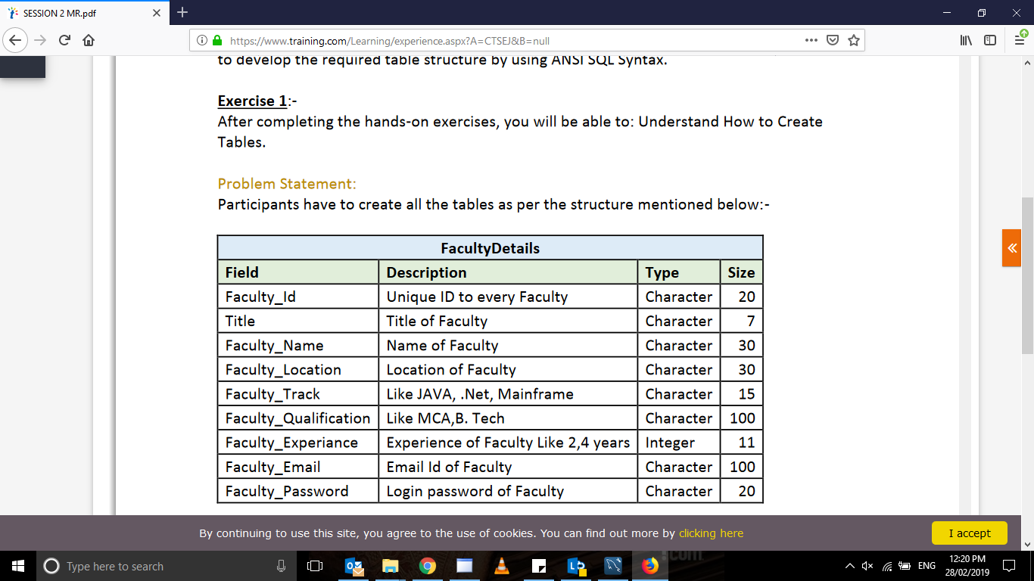

Question1 - create table facultydetail

(Faculty_id varchar(30),Title varchar(7),Faculty_name varchar(30),Faculty_location varchar(30),

Faculty_Track varchar(15),Faculty_qualification varchar(100),Faculty_Experience integer(11),

Faculty_Email varchar(100),Faculty_Password varchar(20));

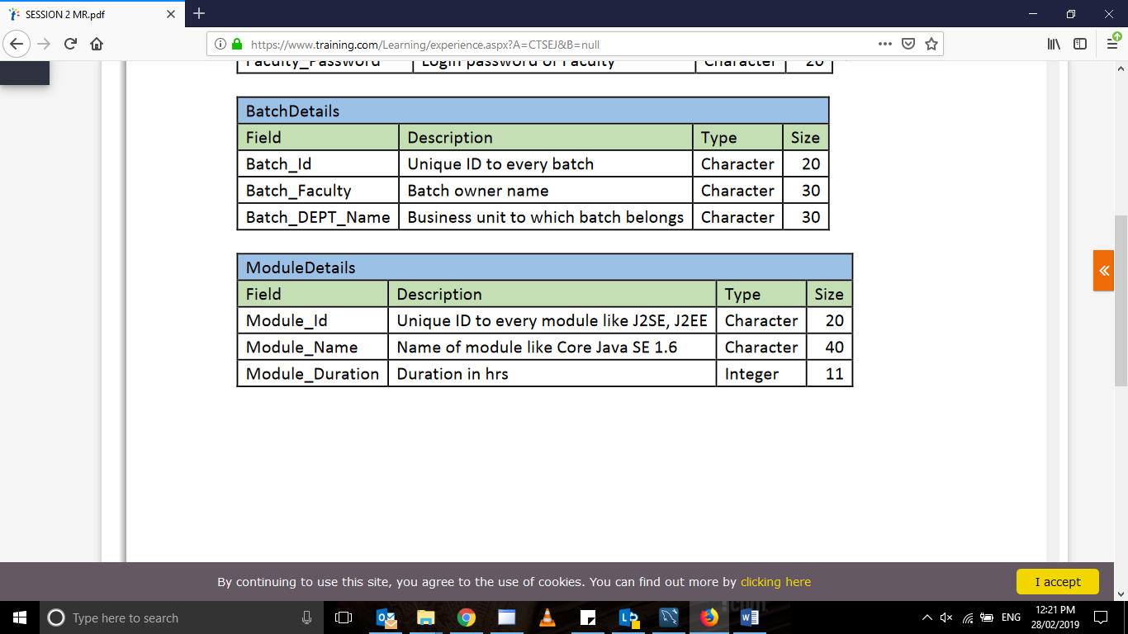

Question 2 -create table Batchdetail

(Batch_id varchar(20),Batch_Faculty varchar(30),Batch_Dept_Name varchar(30));

Question3- create table mOduledetails

(Module_id varchar(20),Module_Name varchar(40),Module_Duration varchar(11));

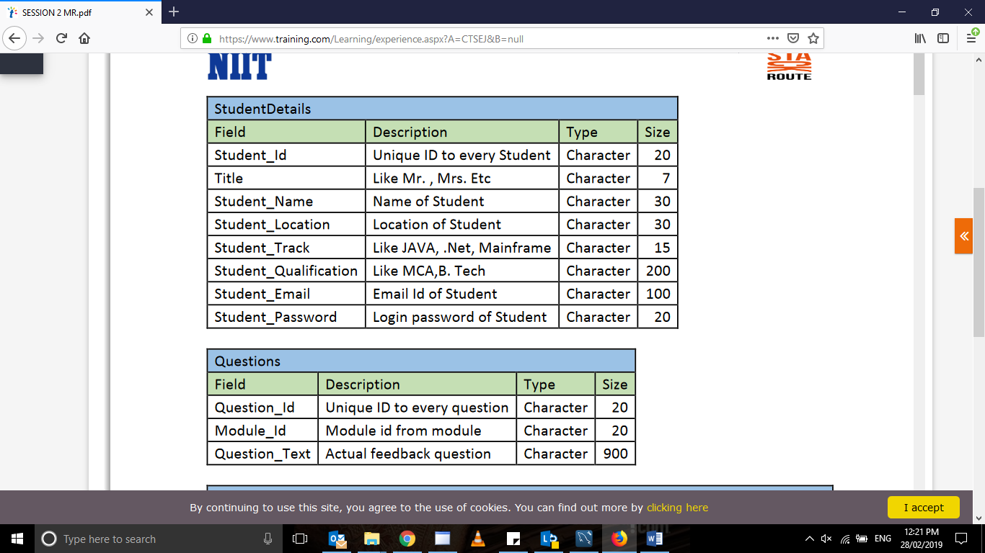

Questin4- create table Studentdetail

(Student_id varchar(20),Title varchar(7),Student_name varchar(30),Student_location varchar(30),

Student_Track varchar(15),Student_qualification varchar(200),

Student_Email varchar(100),Student_Password varchar(20));

Question5 -create table Questions

(Question_id varchar(20),Module_id varchar(20),Question_text varchar(900));

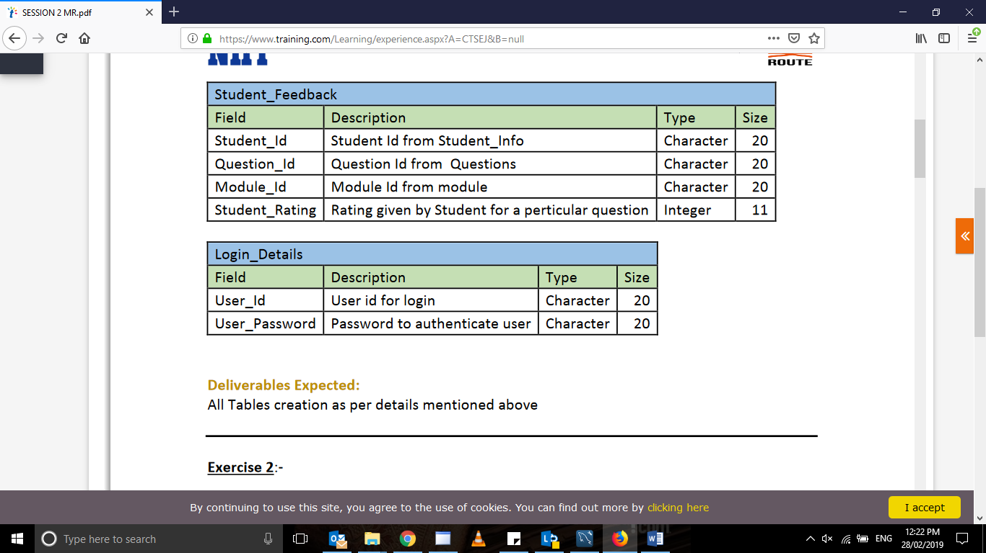

Question6- create table Student_feedback

(Student_id varchar(20),Question_id varchar(20),Module_id varchar(20),Student_Rating integer(11));

Question7- create table Login_Details

(User_id varchar(20),User_password varchar(20));

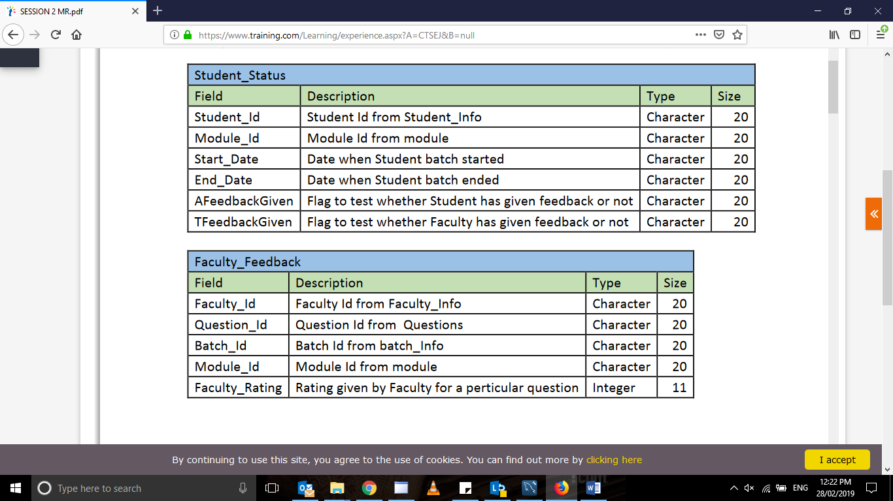

Question8- create table Student_status

(Student_id varchar(20),Module_id varchar(20),Start_date varchar(20),End_date varchar(20),AFeedbackGiven varchar(20),

TfeedbackGiven varchar(20));

Question9- create table Faculty_feedback

(Faculty_id varchar(20),Question_id varchar(20),Batch_id varchar(20),Module_id varchar(20),Faculty_Rating integer(11));